Canby United Methodist Church
1520 North Holly Street Website: www.canbyumc.com
Canby, Oregon 97013 Email: canbyumc@canby.com
Pastor Martha ‘Marty’ Williams Phone: 503-263-6419

Sunday at 11:15 a.m.
In-person & Zoom worship

Church Office Hours:
Monday, Tuesday & Thursday
10 a.m. – 2 p.m.

Pastor Marty:
Tuesday & Thursday
10 a.m. – 1 p.m.

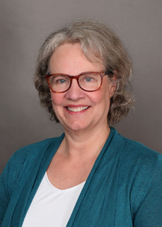

Pastor’s note:
Greetings Canby……
What a delight to be appointed as your interim pastor for the next year!

I have already enjoyed worship with you, yummy pie and soup and getting to know Renna your wonderful office leader.
I look forward to our season of ministry together. I am excited to get to know each and every one of you and what gifts and graces you bring from our Lord for our ministry together.
I am your pastor to encourage, empower and equip us to learn and move into all that God has in mind for you and for us as a community of faith.
Please stop by and let’s get acquainted. I’ll be in the office most Tuesday and Thursday mornings. Oliver (18-month-old labradoodle) and I look forward to meeting you and hearing your story!
Blessings to all…..
Pastor Marty

Rev Dr Marty Williams, Pastor
Clarkes United Methodist Church
Canby United Methodist Church
503-703-8768
williamsmar@msn.com

July Birthdays
07 Bess Milhauser
11 Peggy Yeats
16 Quinn McCormick
20 Phyllis Stuart-Meyer

August Birthdays
01 Kai Laitinen
05 Judy Cooley
09 Pastor Marty Williams
10 Judy Zettergren
21 Omik Oldenkamp Kamat
24 Leta Bunnell

August Anniversaries
06 Curt & Judy Cooley
10 Del & Gail Hildreth

WE’RE ALL INVITED
to Bess Milhauser’s
90th Birthday Party!

This Thursday July 7th beginning at 2:00 pm at Hope Village under the Big White Tent outside on the lawn.

Her son Mark and wife Kathy hope you can stop by to celebrate and wish her a very special Happy Birthday! Family requested no gifts please.

Upcoming:

Month of July

Pastor Marty on vacation - July 18th through 24th

Month of August

Red Cross Blood Drive – August 9, 12-5pm F.Hall
To register – online or call 1-800-Red-Cross

COUNCIL MEETING - August 15th 6pm via Zoom

Lifeline Screening – August 29th 8-5pm F.Hall
To register call 1-800-897-9177

United Women in Faith:

As we near July 1st, we’d like to welcome Pastor Marty Williams!
Our meeting for June was to make pies and a light lunch for Father’s Day, it was a great success, with several people taking home extra slices of pie! We met Pastor Marty, which was a treat!
The first week in July will be Pastor Marty’s first Sunday as our new Pastor. It will also be the first Sunday of the month and we have committed to providing treats after church. So, those willing to help out give Deanna or myself a call. Both of our phone numbers are in the church directory.
We will not meet in August.
In September we will have our Rummage Sale on the 10th. Yeah!
Blessings to all,
Sharon Perez

Blessing Bag ministry:
We want to thank everyone for helping with the blessing bag ministry. We saw a person when we went to Ken’s grandson graduation, he asked us for $2.00, Ken had $5.00 in his wallet that he gave him.
Then when we were coming from work we saw a lad needing money, she had three girls so Ken gave her twelve dollars. We give like Jesus Christ gave.
We hope everyone has a fun summer!
Ken & Deanna Johnson

Care Team:
We wrote 15 cards, 10 text and emails. Remember, sending a card can brighten someone’s day!
Deanna Johnson

Financial Report:

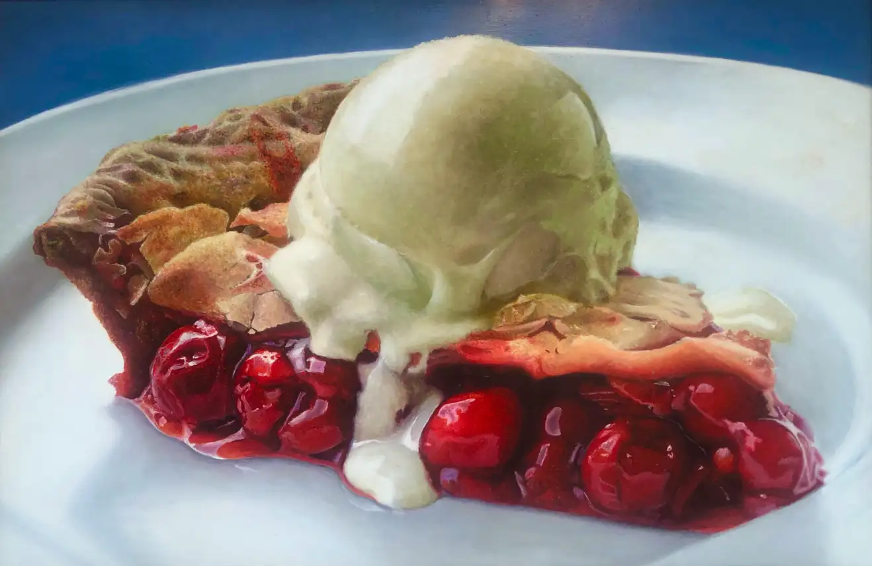

Summer has arrived (along with pie season 😋🥧). While our pie baking skills were a bit rusty we pulled together for a nice event. Even some ants could not spoil our teamwork. Financially the first half of 2022 has been consistently positive. We have covered our expenses including our $1,000 per month support of shared ministries (apportionments) without dipping into our reserves. My monthly messages continues to be thank you for your steady support of our ministry.

The summer is often a time when income is a bit lower. Part of this is routine as the preschool is closed for the summer months. Let’s welcome Pastor Marty and look for opportunities.

I requested another $500 check from recycling. Your continued support makes this happen.

Mark Oldenkamp

