Canby United Methodist Church
1520 North Holly Street Website: www.canbyumc.com
Canby, Oregon 97013 Email: canbyumc@canby.com
Pastor Marty Williams Office Phone: 503-263-6419
Pastor Marty email and phone: williamsmar@msn.com 503-703-8768

Welcome October!

Sunday at 11:15 a.m.
In-person Worship

Church Office Hours:
Monday, Tuesday & Thursday
10 a.m. – 2 p.m.

Pastor Marty:
Tuesday & Thursday
10 a.m. – 1 p.m.

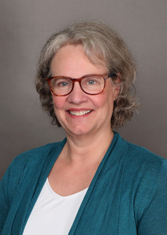

Pastor’s note:
Dear Canby UMC…
It is almost impossible to believe that it has been seven weeks since our precious

Malia did not wake in the morning and went to be with Jesus.

Your care, love and support of me throughout these days has been so appreciated. The cards and hugs have buoyed me daily. Thank you for your grace and patience as my brain has tried to make room for something that it cannot hold. My faith has held me and my family in these days, your prayers have cradled us, and God’s grace has sustained us. Through it all God is revealing His love and care. Something that comforted me a bit, as a single mother having to send my children every other weekend into the care of their father who had assaulted me, was that God loved these children even more than I did and would take care of them.

God loves each of us fiercely and tenderly. Would you be sure and reach out in love—even in this moment to those you love. Life is precious—keep very short accounts with one another.

I love you all and it is a privilege to be called to be your Pastor.

Marty

Blessing to all,
Rev Dr Marty Williams, Pastor
Clarkes United Methodist Church
Canby United Methodist Church
503-703-8768
williamsmar@msn.com

October Birthdays
22 Shirley Wright
26 Bobbie Knapp
29 Sharon Perez
30 Sharon Trimble

November Birthdays
03 Diana Trujillo
12 Ken Johnson
17 Les Zettergren
22 Deana Johnson

If we are missing your Birthday or
Anniversary date, please give the
office a call so we can update.

Upcoming:

Month of October
Oct 3rd – Council Meeting 6:00 pm In-Person

Oct 15th – UWF Meeting beginning at 1:00pm in the Fellowship Hall.

Beginning October 16th, third Sunday of the month,
we will begin our monthly lunch potlucks immediately following worship, bring a dish to share. During the potluck we will have a “Back to Church Gathering” all are welcome!

Oct 24th – Red Cross will be in the Fellowship Hall from noon – 5:00 pm. Call 1-800-Red-Cross or schedule online for an appointment.

United Women in Faith:

Next UWF meeting is Saturday October 15th
Beginning at 1:00 pm in the Fellowship Hall.

November meeting will be Saturday the 12th.

Sharon Perez

Blessing Bag ministry:

Thank you for your prayers for the blessing bags ministry, and your continued support.
Ken & Deanna

Financial Report:

Finance
For the past two months I have been busy with dahlia shows and work travel so I have not been present quite a few Sundays. Our faithful members and

constituents have provided well for our financial needs. Please give yourselves a pat on the back. Below are a few details for those that like the numbers. Renna periodically posts the financial report on the bulletin board outside the church office and I am always willing to tackle a question you might have.
Through September our income from all sources is slightly greater than the expenses for the same period of time. Keep in mind that a fair amount of church maintenance is paid from a designated account that has a declining balance. With the church being quieter as we dealt with Covid impacts, utility costs have been lower while some maintenance issues occurred because of the building and plumbing not being used regularly. Thank you to all those faithful supporters of our church and ministry. It helps that we get some income from other groups such as the preschool, the Apostolic church and Aurora handspinners. Almost 25% of our income so far this year was from church use donations. We have paid 46% of our apportionments through September and if we increase back to $1,000 per month for the balance of the year, we will be at 66%, just under $10,000 total.
You will receive your third quarter giving statements very soon. Please contact the church office if you see anything that does not seem correct. Renna is a GREAT partner with the multiple hats she

wears. Please express your thanks to her when you have a chance. She is amazing!!
Our investment account balances have declined this year as they are subject to market trends. Our investment strategy is such that over the approximately 15 years since the parsonage was sold and the funds were invested, we still have a higher account balance than the original investment. We have used funds each year to support our budget (ranging from $5,000 to $20,000 per year) and once used about $30,000 for parking lot repairs. Since 2009 we have averaged a little over 8% return even with a negative 15% this year. This is amazing. We have a much smaller Trustee account with most of the funds dedicated for music instrument maintenance and a separate Endowment account that has grown over the years. If you are considering or involved with estate planning and have interest in remembering the church with any gifts, we can connect you with our financial advisor to answer questions you may have.
2023 budgeting is beginning. I would expect the budget to be similar to 2022 with a small change to staffing, some increases in utilities and city services and about a $4,000 reduction in our calculated apportionment share. We will have more on this for our All Church Charge Conference in early December. I am hopeful to reduce our reliance on allocation from the Pastoral Housing account for 2023.

I just requested another $500 check from the Bottle drop recycling account. Your support of this program is amazing. While we do not have a current target for using this account there have been several times it has made some program expense or an equipment purchase possible. It is easy and a good thing to do. Consider asking your friends or neighbors to donate their recyclables and we will do the work for them. Aluminum cans, plastic bottles and glass bottles are all worth a dime. Just look for the Oregon 10 cent somewhere on the label. Canned fruit, vegetable or meat containers are not redeemable. I try to keep a supply of Blue bags in the Narthex which saves a little of my time for getting them turned in.
Mark

Life of the Building!

As you have noticed we are working on the parking lot restripe. This is a large project and we thank Bob, Ken and Joe who are willing to take this on, it is greatly appreciated and a much needed face lift for our parking lot, thank you!

REMINDER!

Sunday November 6th
Don’t Forget!

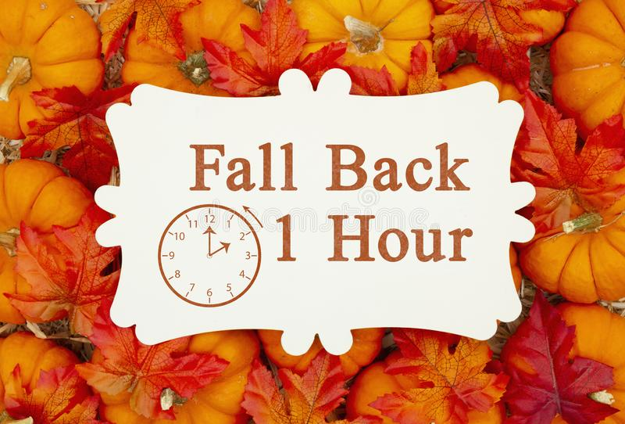

AUTUMN PRAYER,
Abba, Father, the trees are ablaze with your glory. The seasons change, but you never do. You are always beautiful,
in the green and freshness of spring
as in the golds and reds and chills of autumn.
Make me like you. Let my life reflect your beauty, season after season,
as the calendar of my life turns and turns.
The trees are letting go of this year’s foliage.
Help me let go of both blessings and burdens, and surrender them both to your loving care.
Fallen leaves pattern the ground with variety.
So design my own fallings and failings
into whatever design will please you most.
In Jesus’ name, I pray,
Amen.

